**Data Mining file**

**Uday Pratap Singh**

**23/SCA/BSC.IT/008**

1. Demonstration of preprocessing on dataset employee.arff

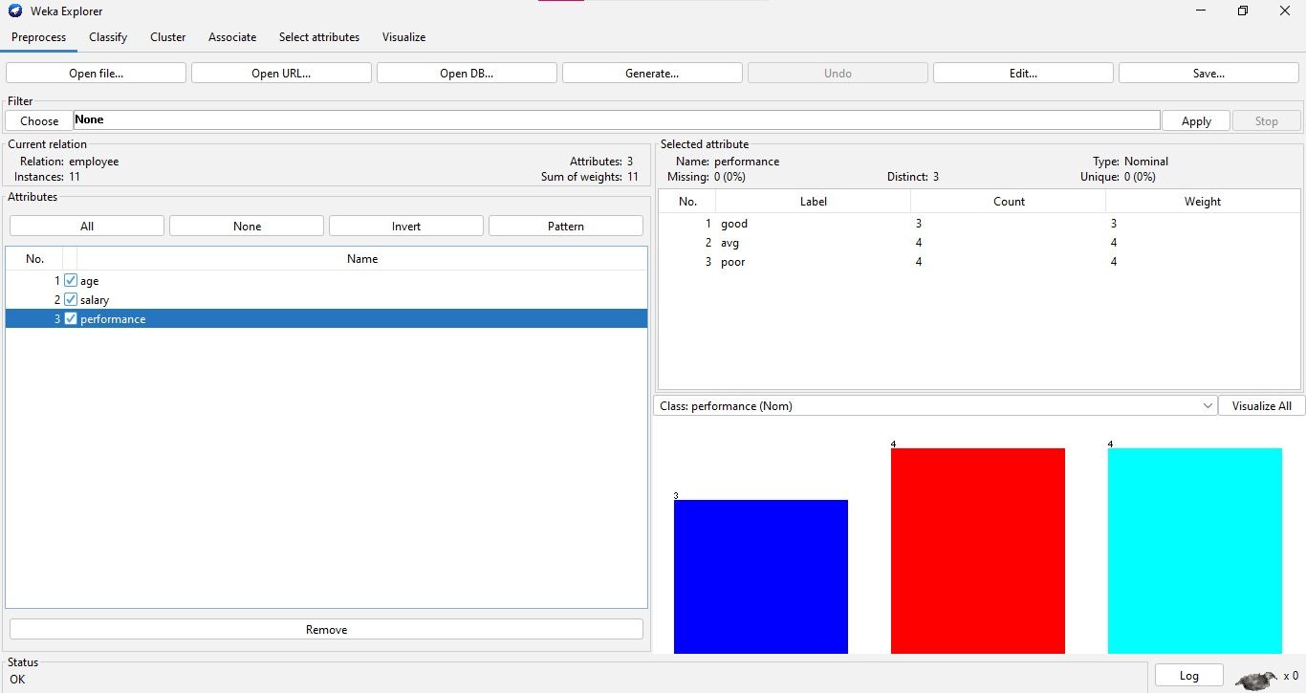

2.Demonstration of preprocessing on dataset employee.arff

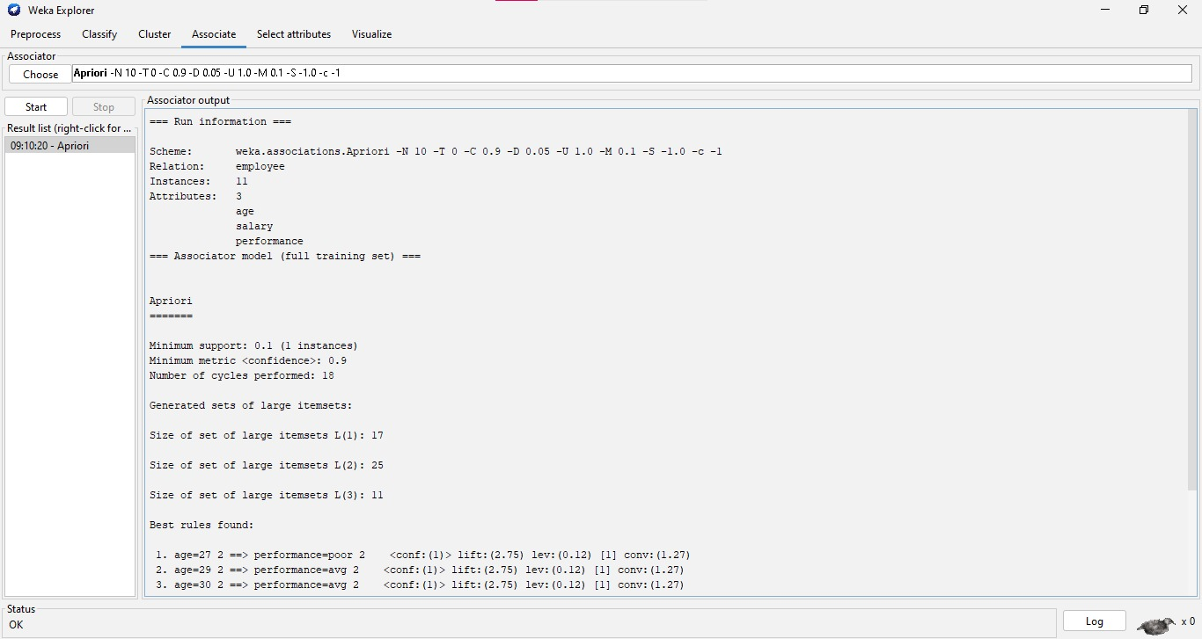

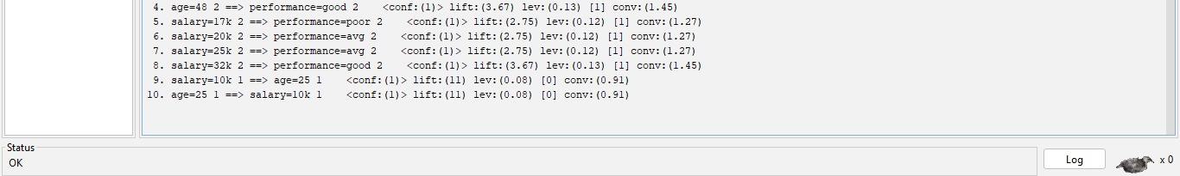

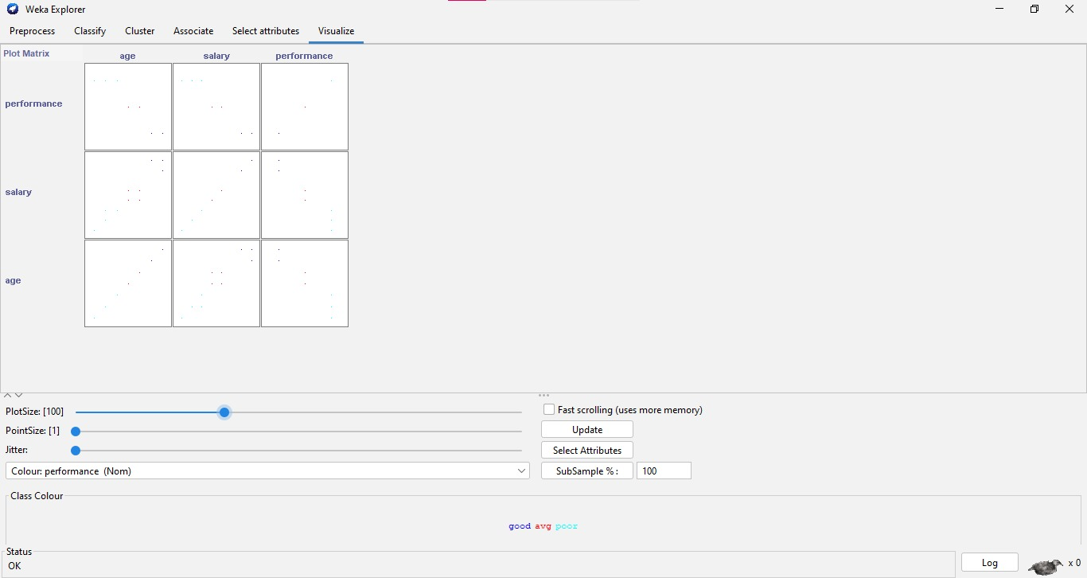

3. Demonstration of classification rule

process on dataset employee.arff using naïve Bayes algorithm

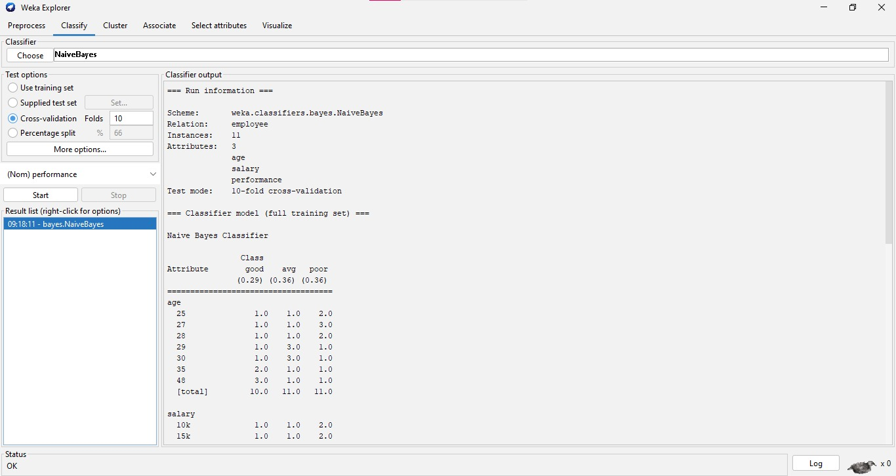

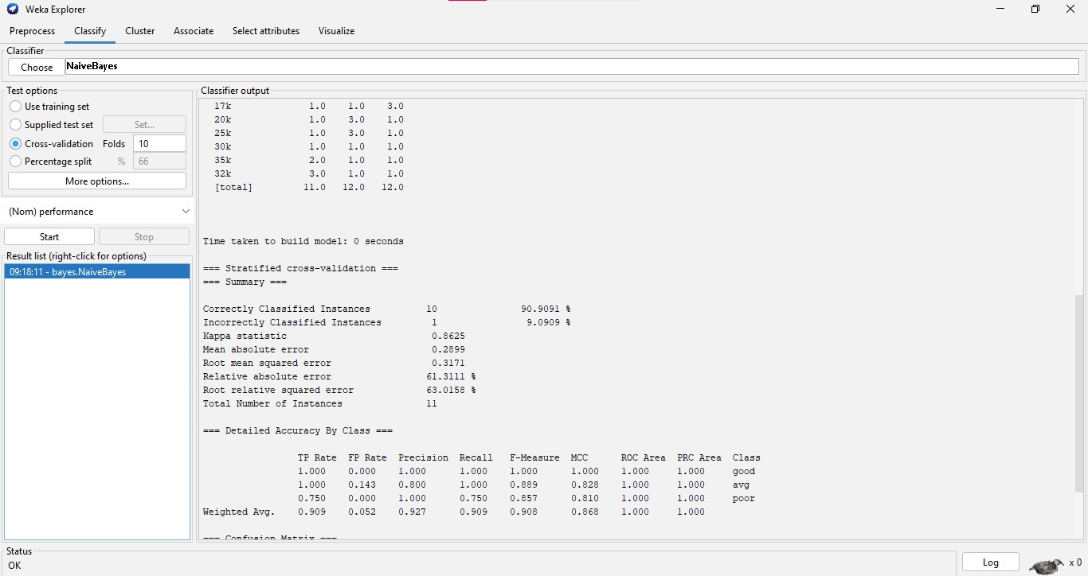

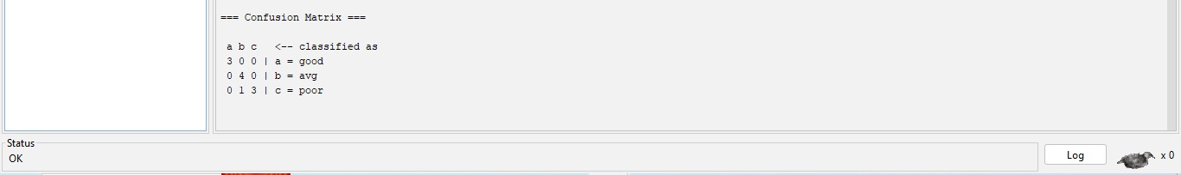

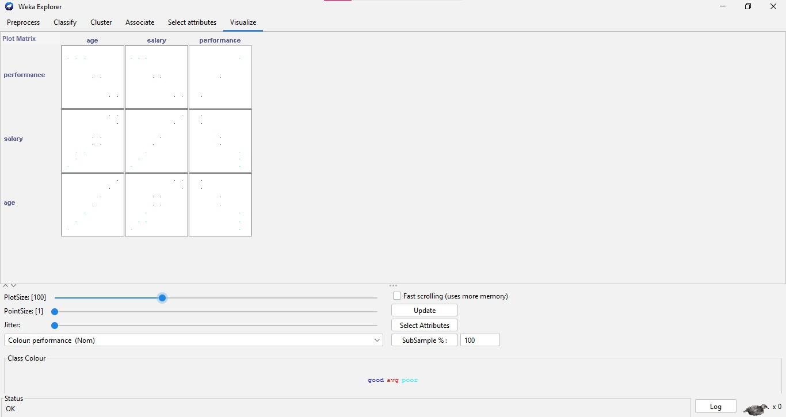

4. Demonstration of clustering rule process

on dataset Employee.arff using simple k- means

